**IMAT3906: Shader Programming Report**

|  |  |
| --- | --- |
| Full Name: Ruya Kumru-Holroyd | P Number: P2512547 |
| GitHub Username: RuyaKH | Word Count: 2039 |

**Introduction**

The goal of this study is to explain the function and responsibility of each stage in this programmable graphics pipeline. It is to describe the theory and practice of full shader programming in OpenGL, as well as how it has been implemented into a programmable environment, in this case, Vertex and Frag shaders complied into a graphics program.

Toggle keys for the Shader Program are listed at the end of this report.

**Lighting models**

We use a Blinn Phong lighting model in this shader program to make objects look more realistic with its three light components: ambient, diffuse, and specular. We use Blinn Phong as it handles angles that are greater than 90 degrees better, as well as edges. It also looks better with a larger exponent compared to traditional phong.

Ambient lighting illuminates the whole scene and lights up all the objects evenly, as the environment scatters the background light so much that it is impossible to determine the direction. Ambient = $L_{a}$ $K_{a}$.

Diffuse lighting allows models to look shaded and more realistic adding a sense of depth to the model. Because light arrives from one direction, it can be brighter when directly on a surface than from a side angle. Once the surface is hit, the light is spread equally in all directions. Diffuse = $K_{d}L_{d}\cos\left(θ\right)$

Specular lighting is the result of total reflection of the incident light in a concentrate region, based on the reflective qualities of surfaces. The quantity of specular highlight visible is determined on your viewing angle. Specular = $K_{s}L_{s}\cos^{n}\left(φ\right)$

**Light casters**

The first light caster is Directional light applies ambient, diffuse, and specular lighting which just creates a simple light that floods a scene, with no position just direction and no attenuation applied. Directional light is often compared to the sun in the description of the light source as it is infinitely far away.

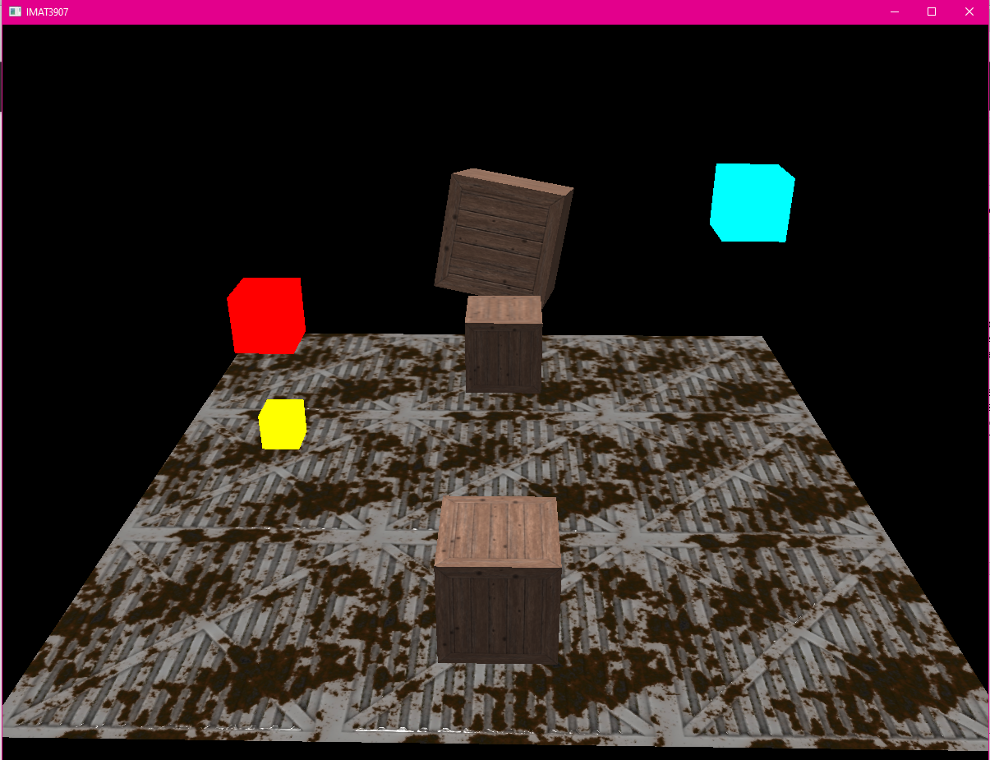  
Figure 1: Directional Light only in my shader program

The second light caster, Point light is a light ray that fades out over distance. This can be compared to light bulbs in real world. Because it has a location in world space, you can place multiple point lights in a scene. I decided to add three different coloured point lights in my scenes at different positions to test out doing multiple point lights and to make the scene more interesting and visually appealing.

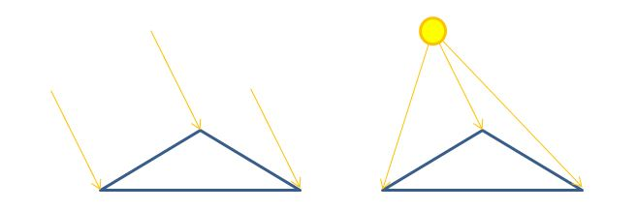  
Figure 2: Point Light (right) demonstrated on triangle compared to Directional light (left)

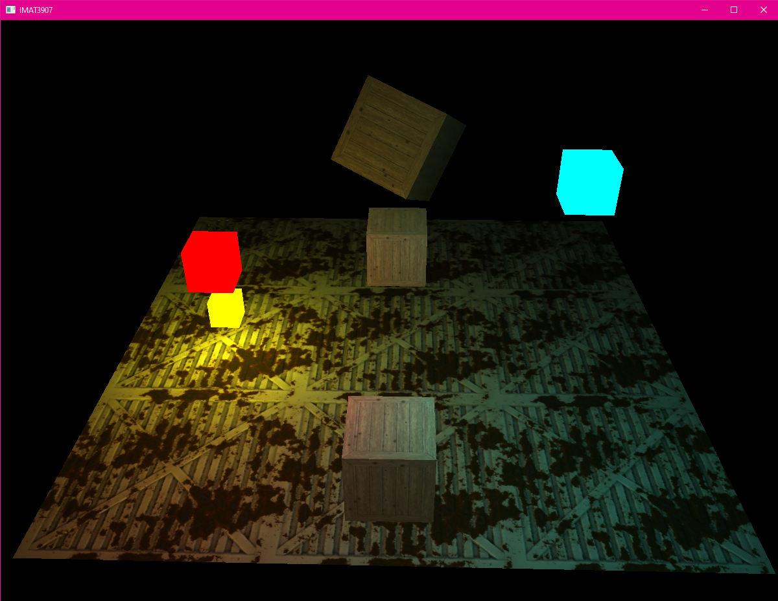  
Figure 3: Point lights only, with rendered light cubes representing position of point light in world space, to be used for bloom later.

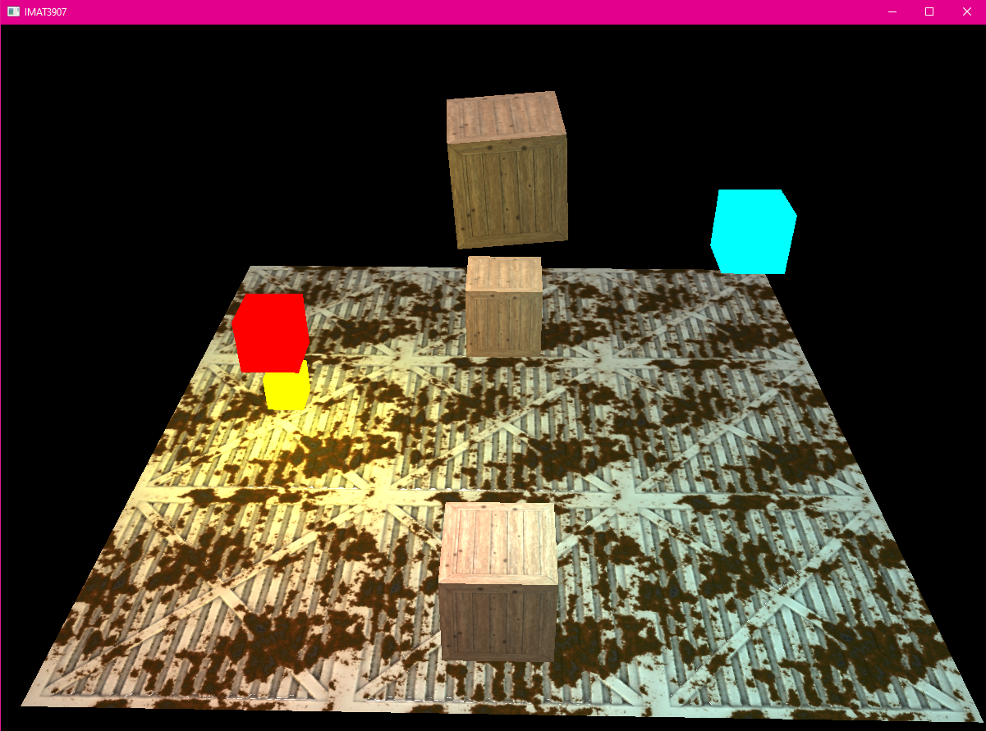  
Figure 4: Point lights and Directional lights together

We can apply attenuation, the process of reducing the intensity of light across the length of a light ray's journey, to the point light to make the light appear brightest on nearby objects and reduced on further away objects. $A=\frac{1}{A_{c}+A_{L}D+A_{Q}D^{2}}$

The third light caster implemented is Spotlight, they are restricted point lights, light rays that are exclusively emitted in a specified set of directions, shooting them in a specific direction, and are typically cone shaped. A real-world example is a torch. In my shader program, I added a spotlight to my camera view, to act as a torch in the scene, and coloured it green so it was clearly visible compared to other lights already in the scene.

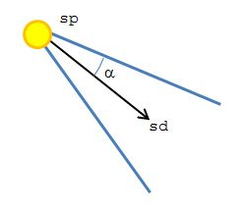

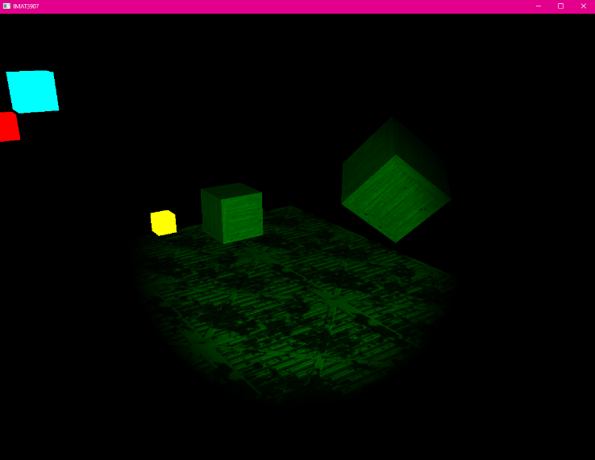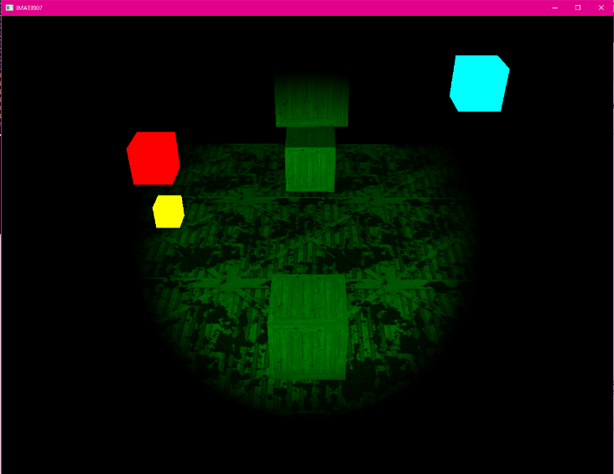Figure 5: Cone shaped spotlight with variables

Figure 6 & 7: Spotlight only, attached to camera front so moves with camera

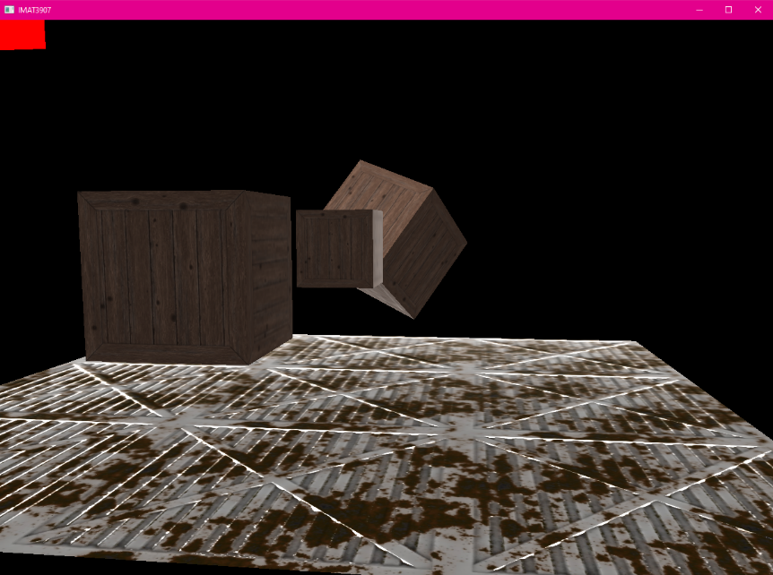The final light caster is Rim Lighting, this acts like a backlight in the scene and is cheap to implement and gives off a nice effect that is important when used in games for atmosphere and mood. In is controlled using brightness and a sharpness factor. $L_{rim}$ $= C_{rim}{\left(1.0-N.V\right)}^{Prim}$.

Figure 8: Rim lighting, also known as back lighting, in the scene with directional light

**Textures**

Textures are used in the shader program through a renderer which loads the textures using stbi_image, assigns them to the shader through uniform sampler2D and applied to the objects such as cube and floor. The textures applied to my scene are shown in the figures above, the one attached to the cubes is a wood crate texture and the floor texture is corrugated metal. These were taken from the 3D texture website, link in references. You can also apply different textures that are within the textures folder, by changing the filename.

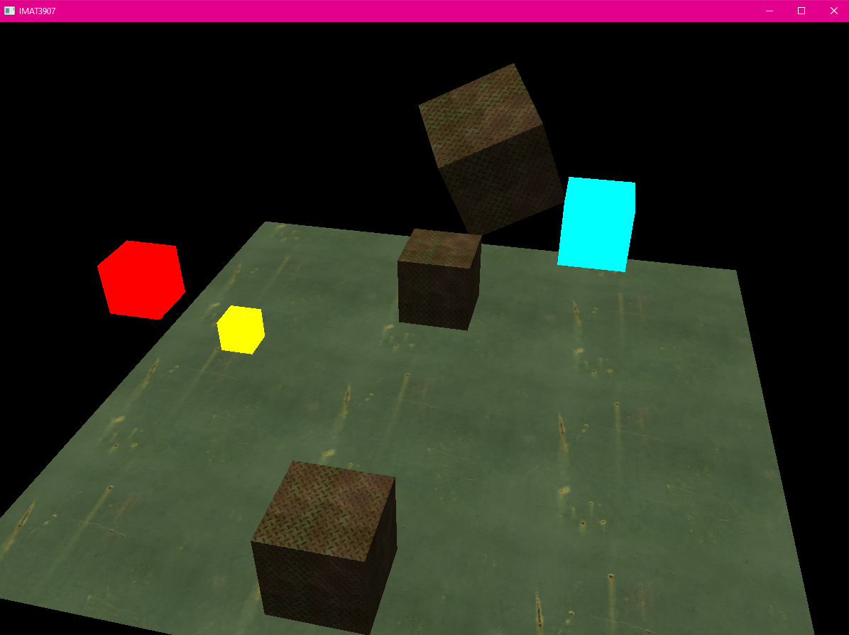  
Figure 9: Metal Plate and Metal Rust textures loaded instead

Also, using sampler2D means we can add layers of textures onto our objects, starting with a diffuse layer which is the base colour/texture, then adding a specular texture which creates shine highlights to parts of the textures, and other sampler2Ds can be added as we go along to create things such as normal and parallax mapping.

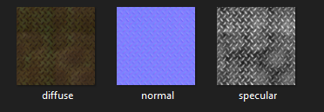  
Figure 10: Metal Plate uniform sample2D textures

**Normal Mapping**

Textures help make models look realistic, but when looking closely you can see the flat surfaces below. Normal mapping adds detail without increasing the number of vertices in the model.

A normal map expresses normal vectors in tangent space, where normal always points roughly in the positive z direction. Tangent space normal mapping is implemented using a TBN matrix of Tangent, Bitangent, and Normal vectors which create a coordinate system, calculated by:

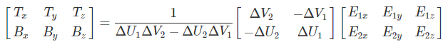

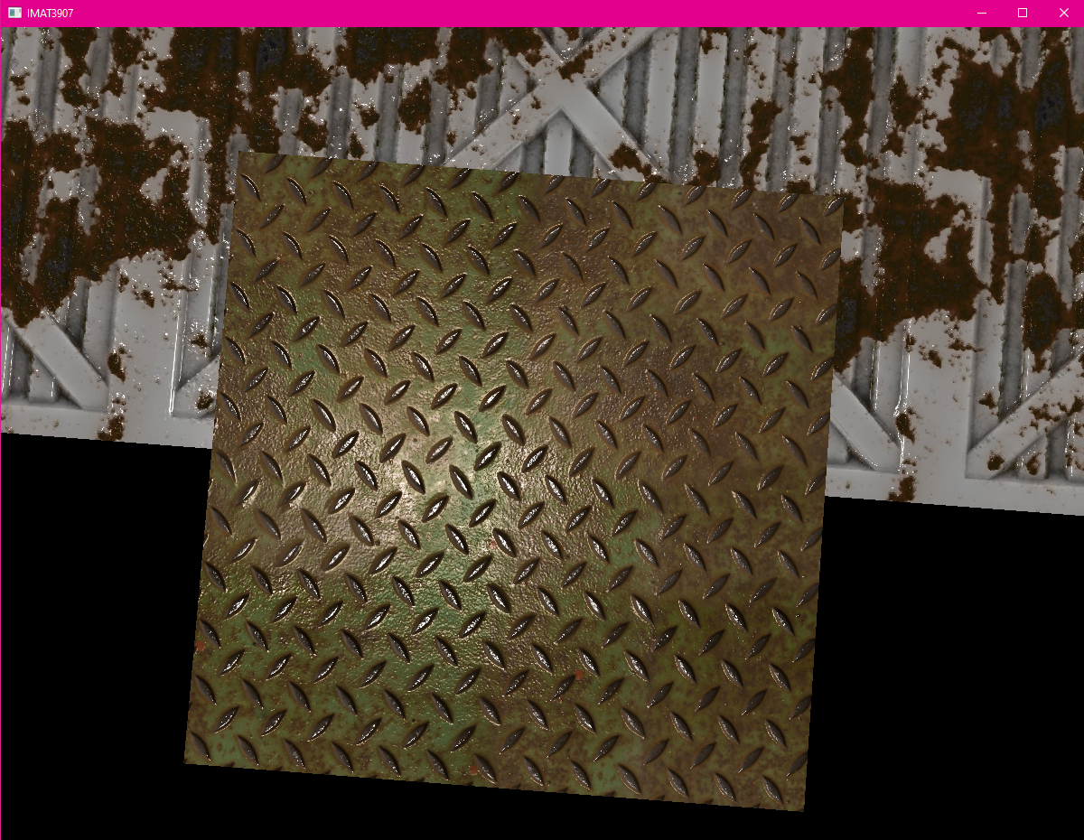  
Figure 10: Tangent space Normal Mapping on metal plate texture on cube

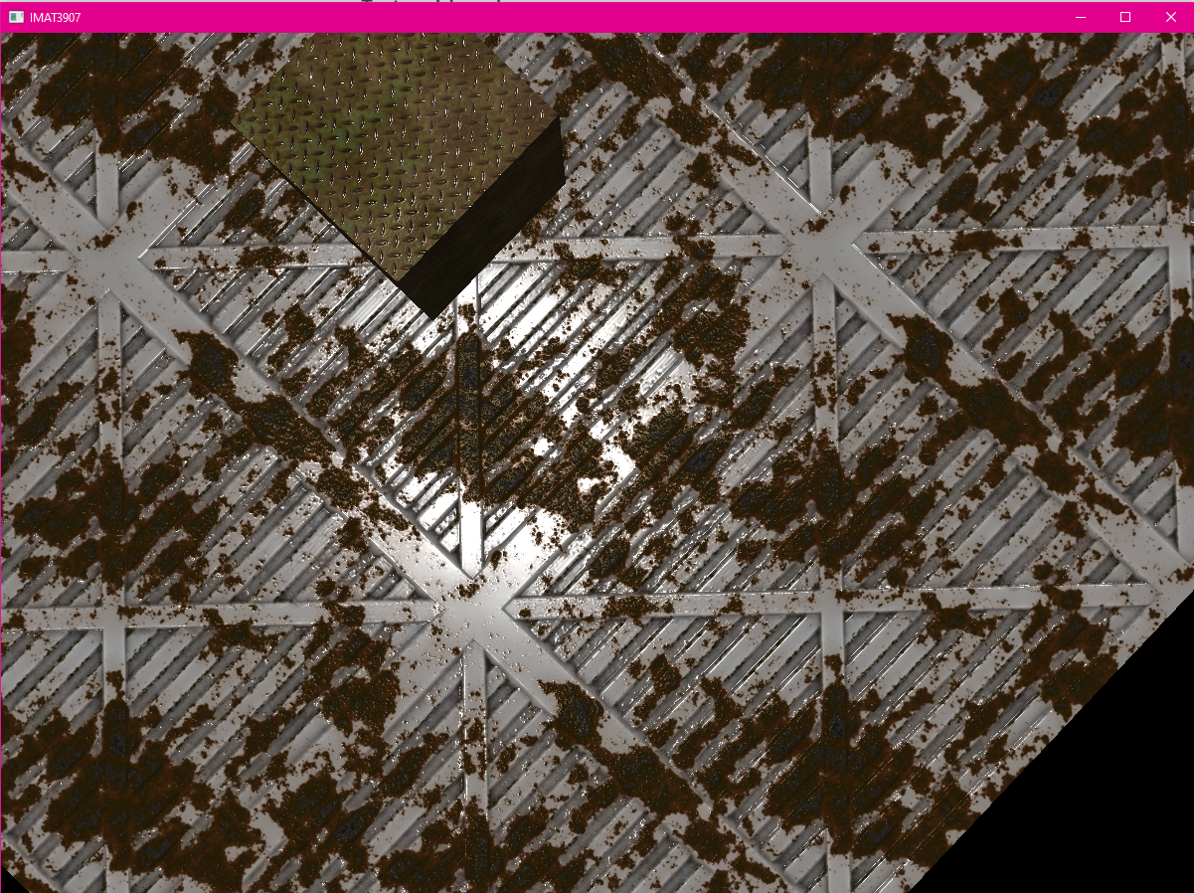  
Figure 11: Tangent space Normal mapping on corrugated texture on floor

**Parallax Mapping**

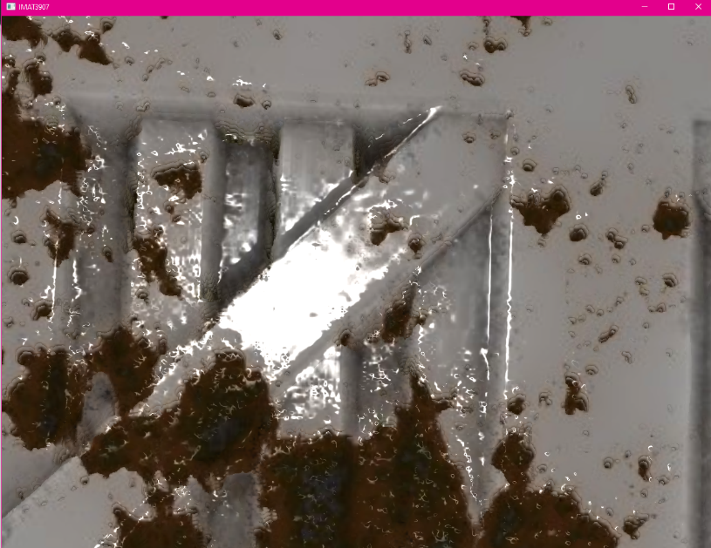Parallax is like normal mapping, but it adds more detail and sense of depth to the texture, it is typically used on walls or floors. I applied steep parallax mapping, which is an improved version of parallax mapping as it takes multiple samples instead of just 1 to better pinpoint the parallax vector. Since the metal plate texture did not have a displacement map texture, but I wanted to test it out on the cubes as well, I changed the cube to a wood crate texture, seen in earlier figures, to give it just parallax mapping.

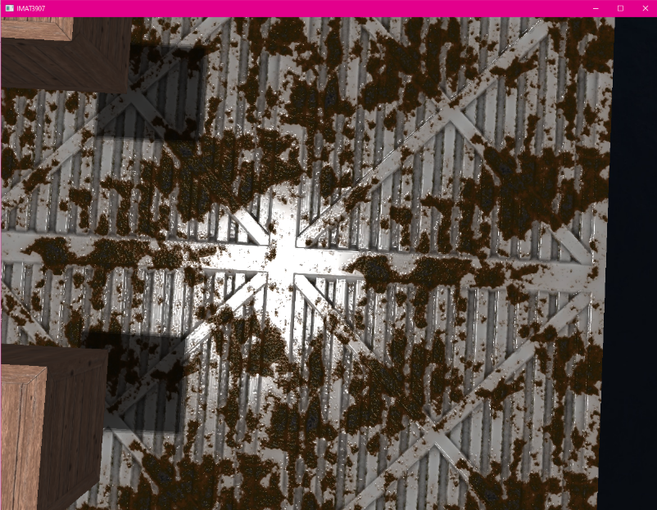Figure 12 & 13: Steep Parallax Mapping on floor from afar and zoomed in

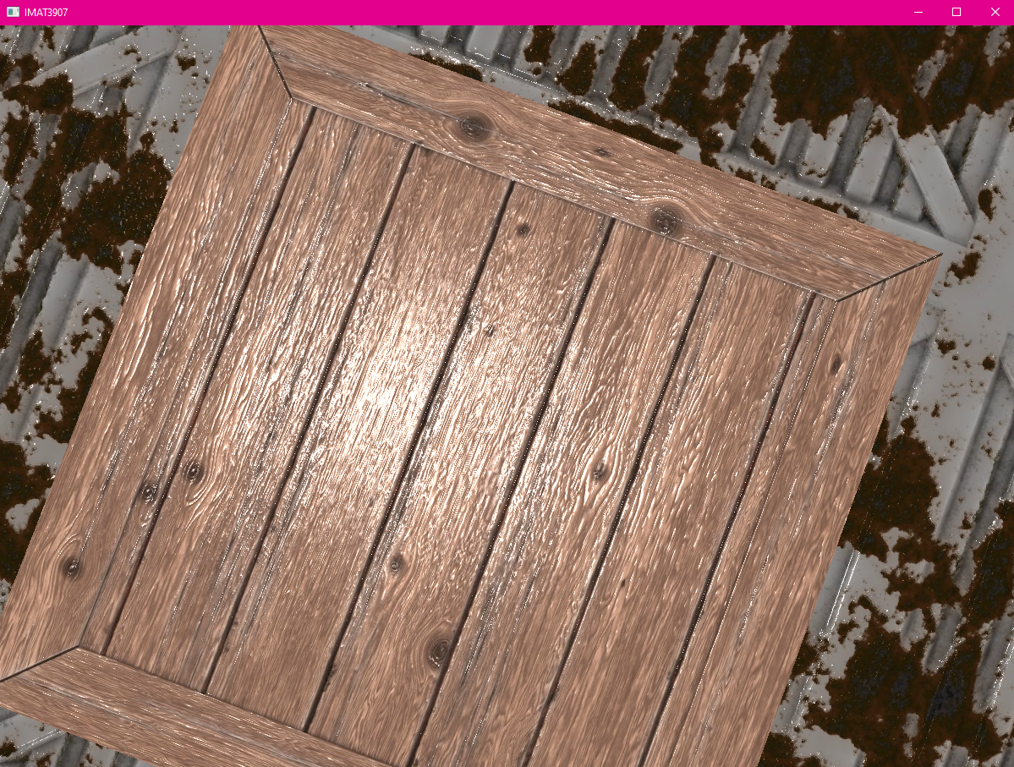  
Figure 14: Cube parallax mapping applied with wood crate texture

**Framebuffers**

A framebuffer is a group of buffers that can be utilised as the rendering target. Up until this point we had been using the default frame buffer that is provided to us by OpenGL, but we also can we can create our own colour and depth framebuffers. I first created a colour buffer which renders the scenes in previous images, and a depth buffer that renders the cubes and adds depth to the scene with closer cubes being darker and further away ones being lighter.

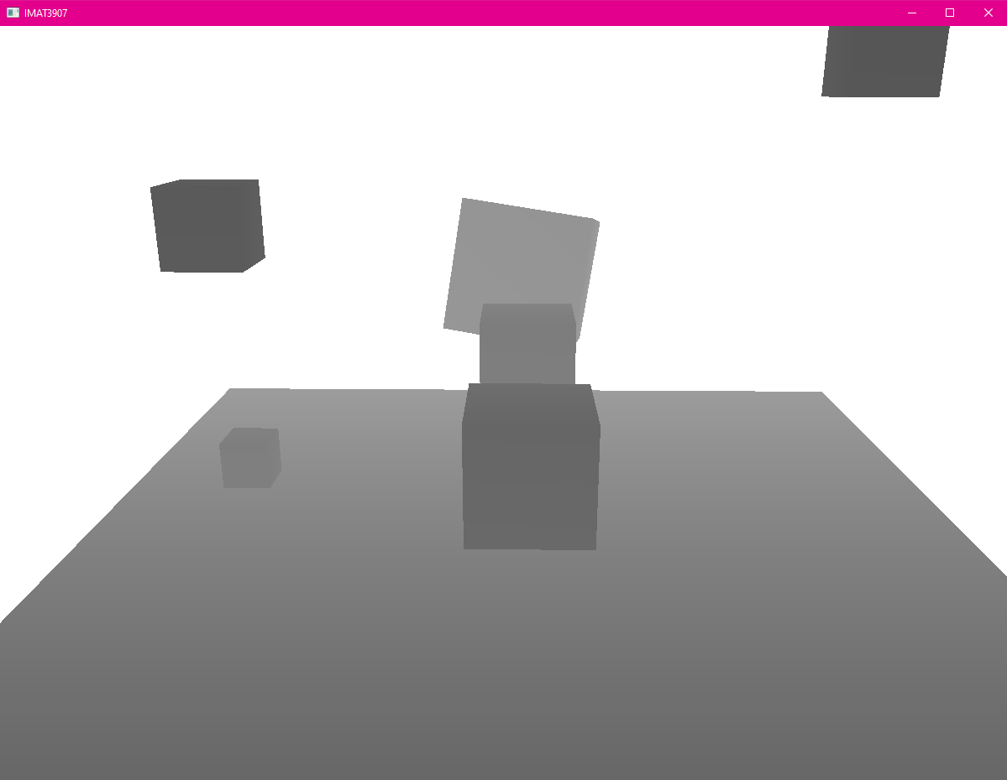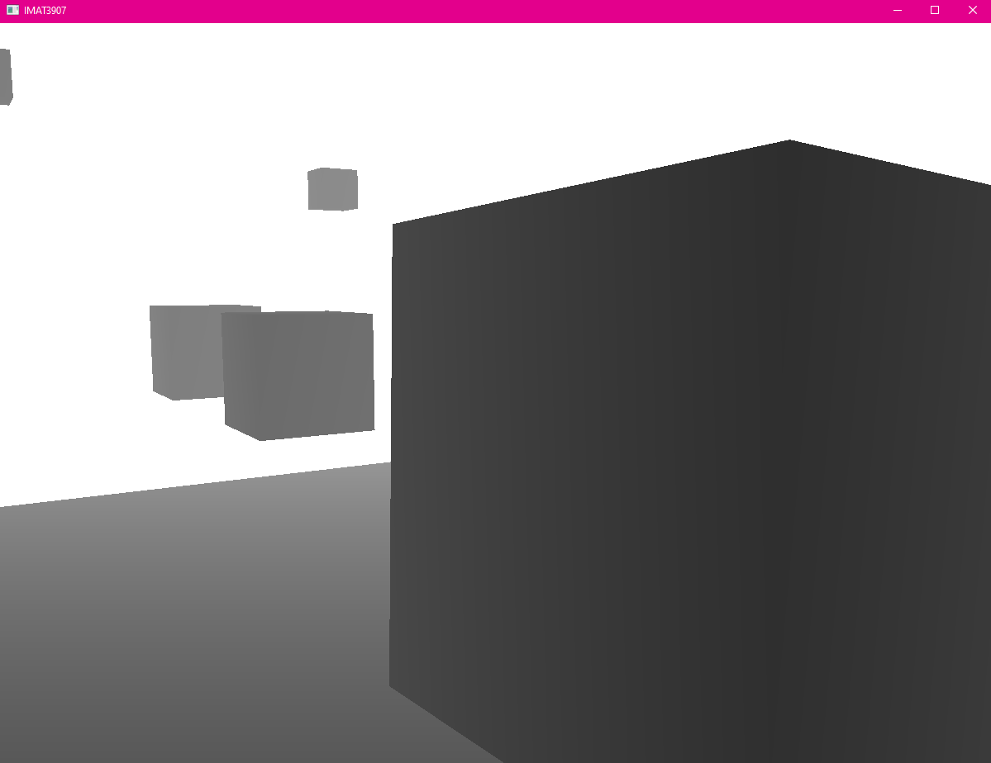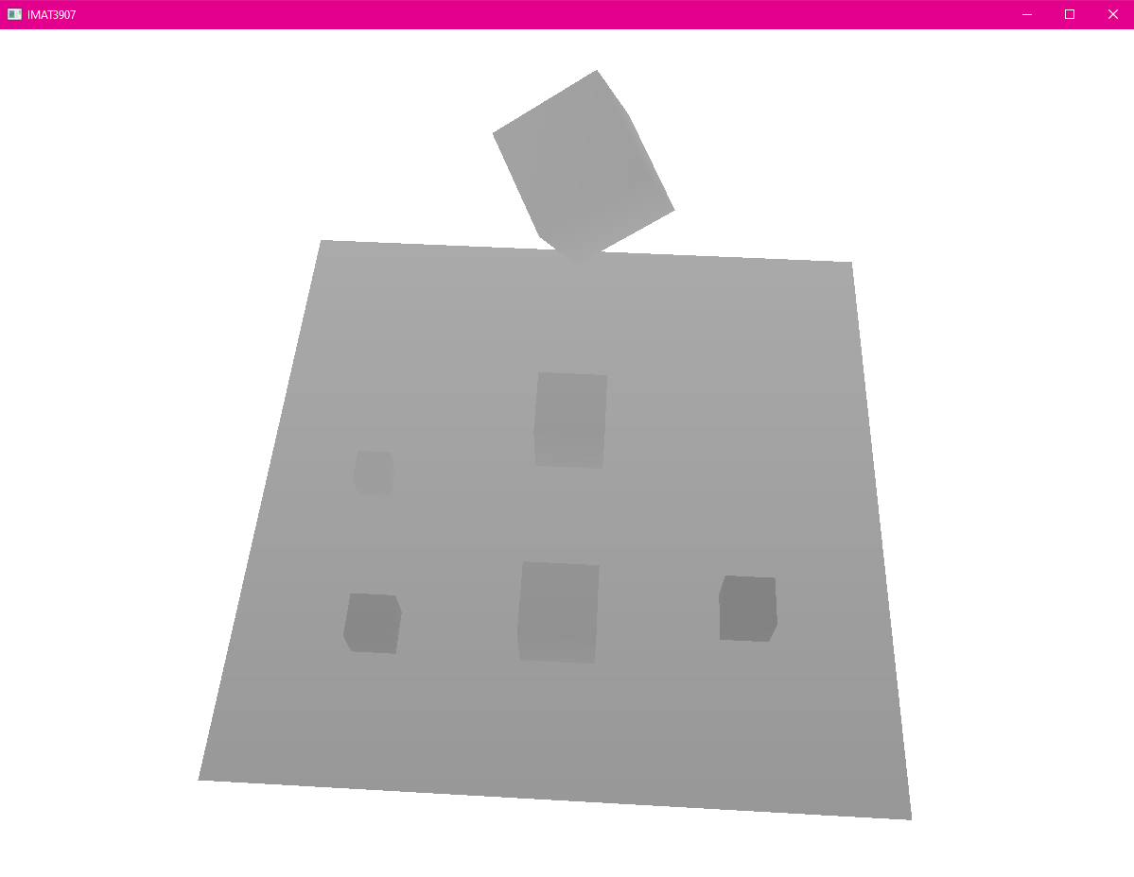  
Figure 15, 16 & 17: Depth attachment at different camera angles, closer objects darker than further away objects.

**Post Processing**

With the creation of the colour frame buffer, the scene can be rendered at once and post processing techniques can be used. I had made a post processor shader for the creation of the colour framebuffer and used that as a main point for my different techniques, using uniform bools to toggle the different filters, listed at the end of the report.   
  
The first one I implemented was Reinhard tone mapping, which darkens the scene and makes it less bright, balancing out the brightness in the scene. I like how it looks with all the light casters included as it brings down some of the harsher brightness some of the lights can bring.

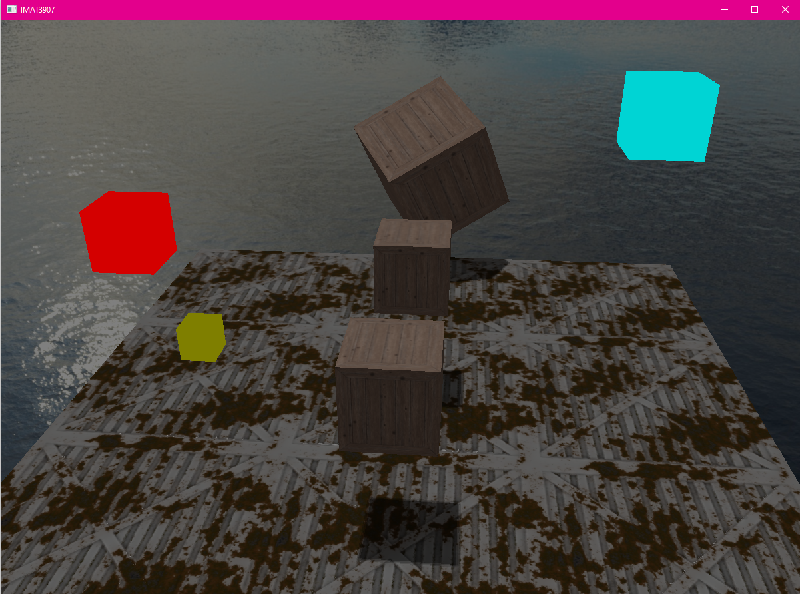  
Figure 18: Reinhard tone mapping with only

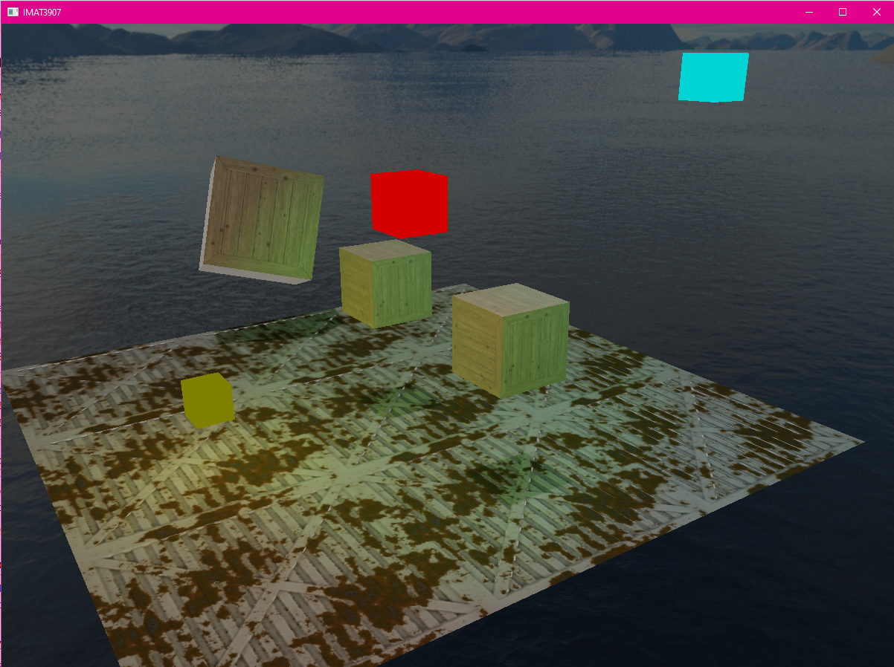  
Figure 19: Reinhard tone mapping with all light casters

I found through the Learn OpenGL advanced lighting page on HDR that you could also add a gamma correction filter to Reinhard tone mapping, using a gamma constant of 2.2. When I did this, it brought the brightness up of the scene and gives it a nice filter, this can be further extended by adding exposure, but when I tried to upscale it, the scene is overwhelmingly bright, so I left the exposure at 1.

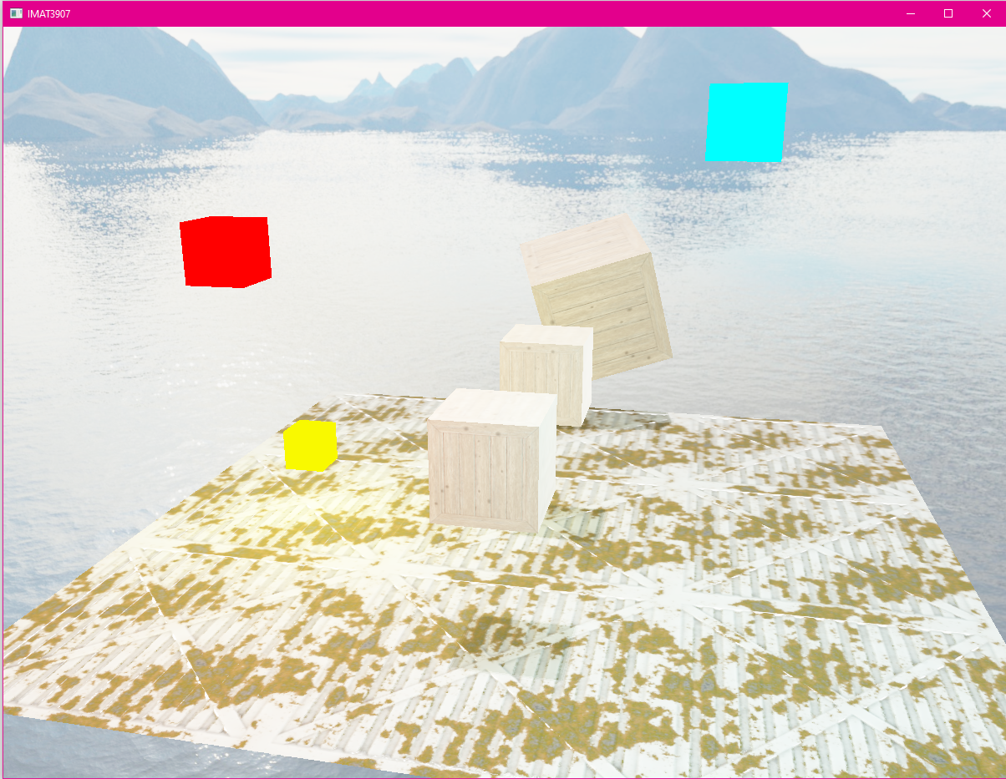  
Figure 20: Gamma correction filter with 3.0 exposure and point lights

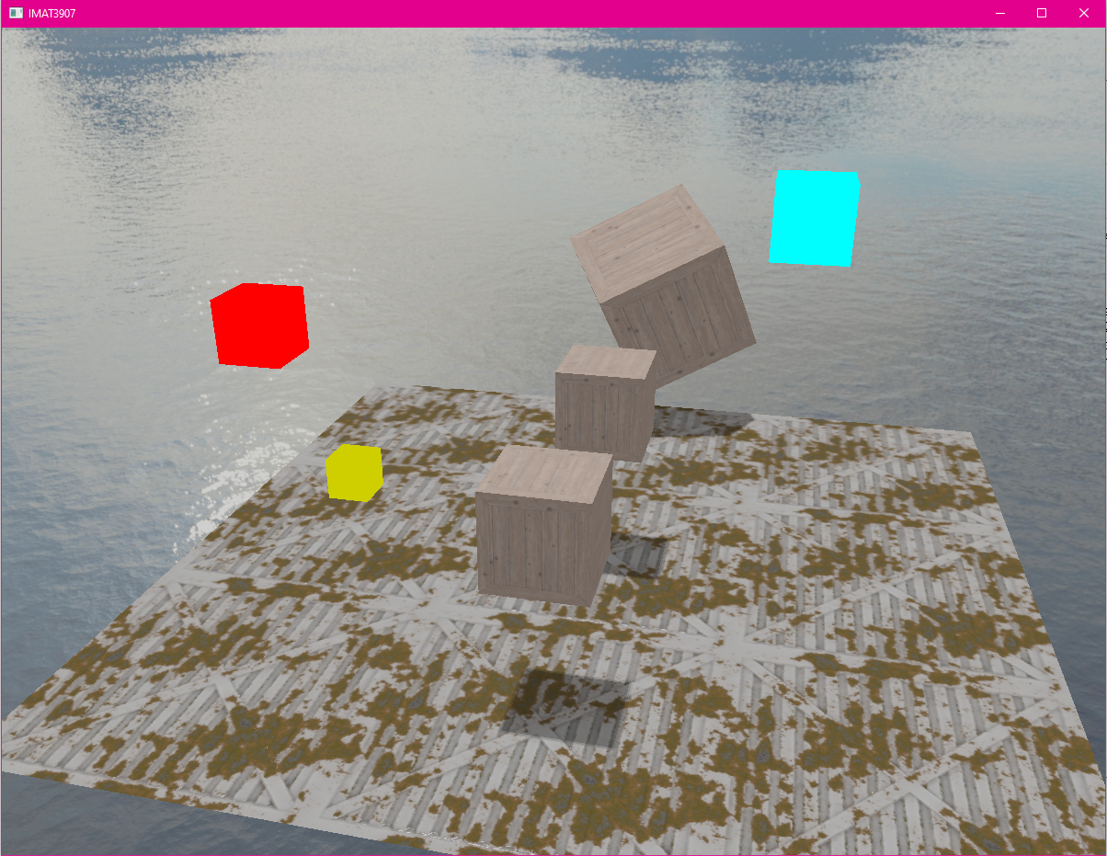  
Figure 21: Gamma correction filter with 1.0 exposure

I also included toggle keys for invert colour and greyscale to show what is possible with the post processor shader and frame buffer.

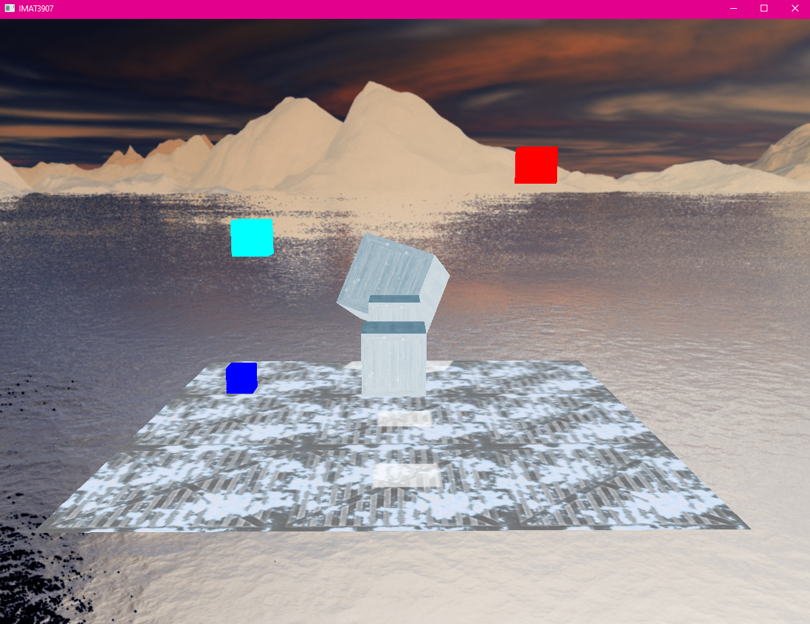  
Figure 22: Invert post process filter, skybox inverted colours look nice

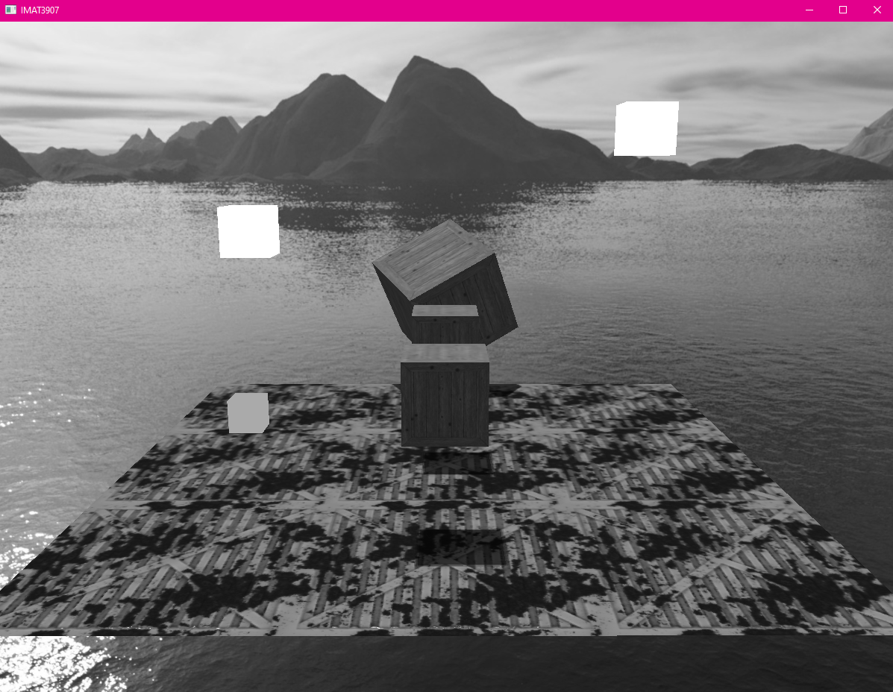  
Figure 23: Greyscale post process technique

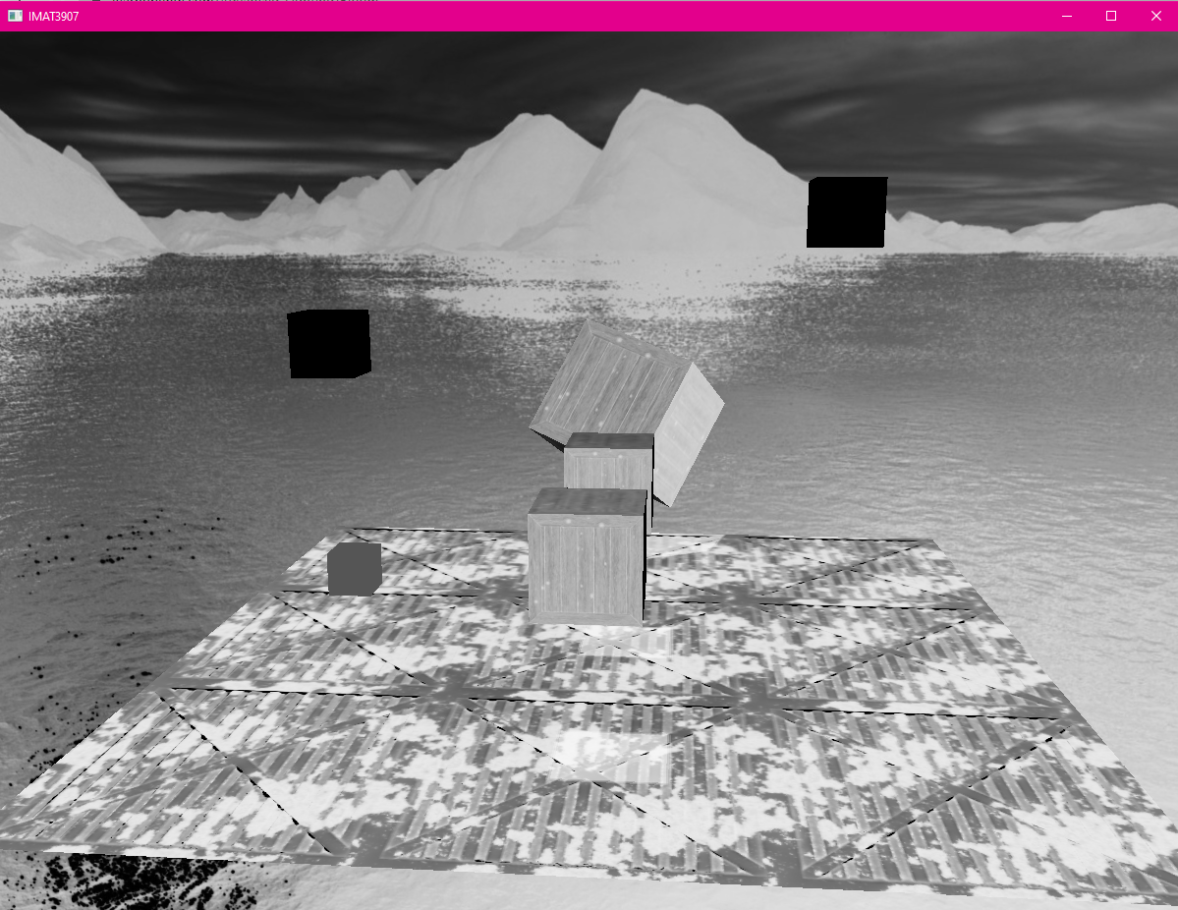  
Figure 24: Invert and Greyscale combined as well as rim lighting

A gaussian blur is created with its own frame buffer to blur the whole screen, and so it can be used for bloom and depth of field.

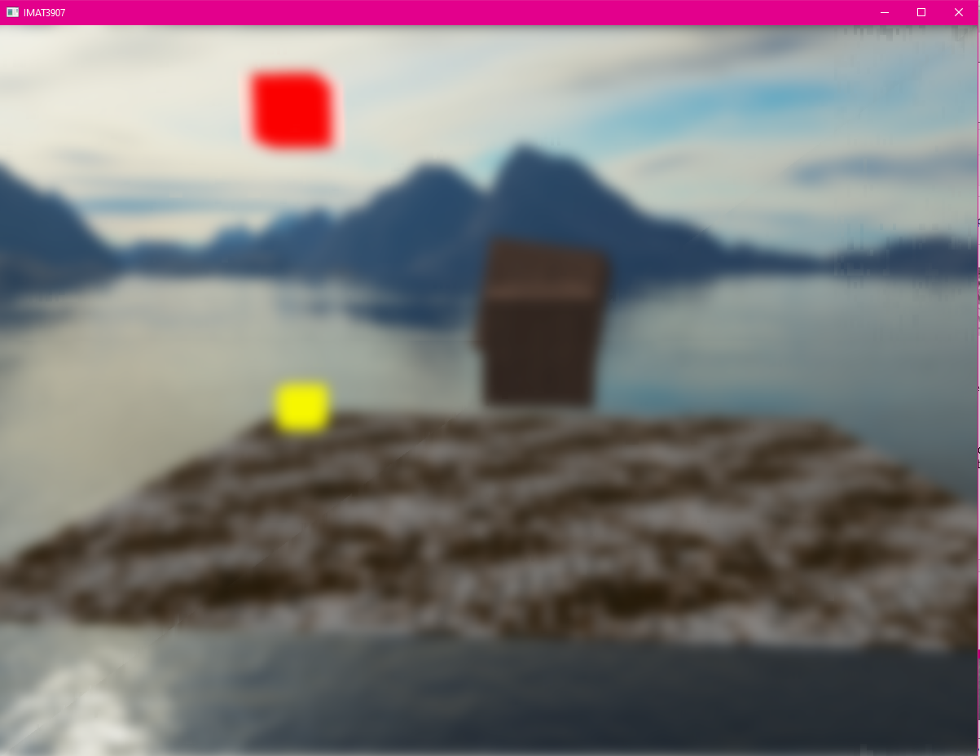  
Figure 25: Gaussian blur in scene

Bloom uses the blur framebuffer and a brightness value to add bleeding to a light source, I created a toggle key to see how much brightness would be picked up by the value set.

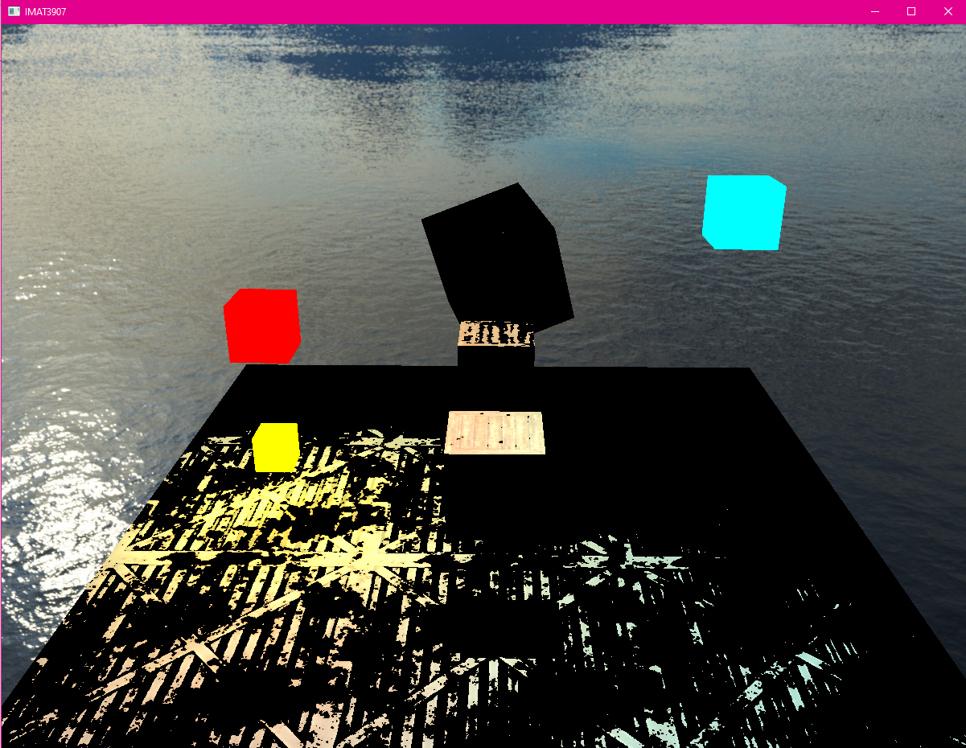  
Figure 26: Brightest parts of the scene toggled

I used Reinhard tone mapping with a gamma correction filter in my bloom shader which adds to the ambience of the scene and gives it a nicer look overall, but I used a lower gamma constant of 1.2 in this shader compared to post process’ 2.2, so the bloom did not look overpowered. But can use exposure set in the source code to make bloom look overpowered or less if wanted to.

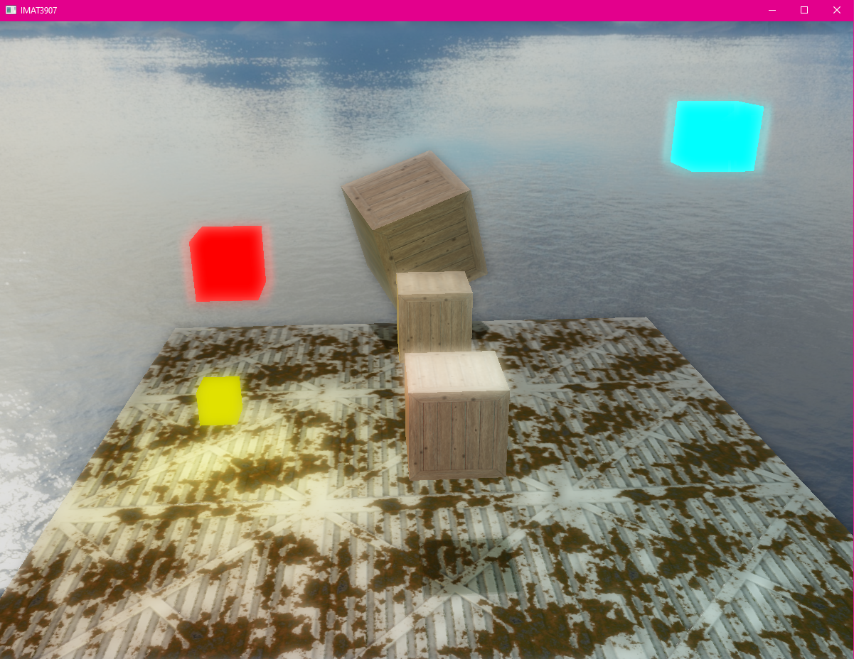  
Figure 27: Bloom with 1.0 exposure and point lights

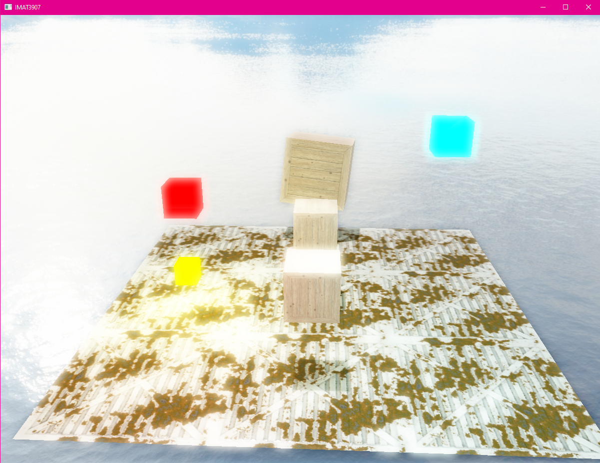  
Figure 28: Bloom with 3.0 exposure and point lights

**Shadow Mapping**

Occlusion causes shadows, which are caused by a lack of light. The thing is under shadow when the light beams from a light source do not reach it because it is obscured by another object. They make the scene look more realistic.   
To do shadow mapping, I created a depth map buffer and a shadow map shader attaching them to their own viewport with its own shadow width and height and took in an orthographic camera that used light projection and light view to create a light space matrix, compared to the colour buffers perspective camera and rendered a depth map to the screen.

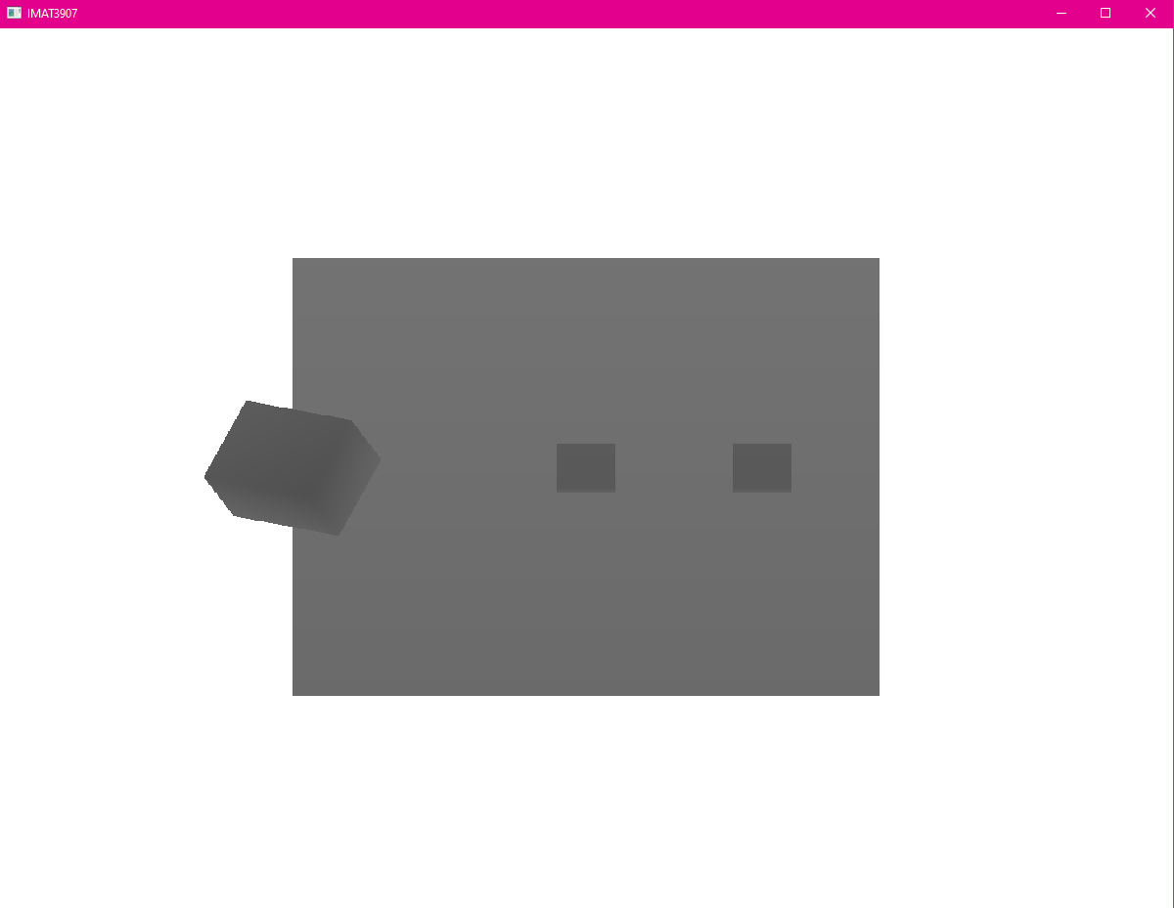  
Figure 29: Shadow depth map

With the depth map being rendered, I could render the cube and floors using the shadow map shader and render the shadows to the screen. There was some shadow acne and kernel problems to begin with, but by adding a bias to the shadows and two for loops to create a kernel matrix, the shadows worked and looked smooth. The shadows do appear in images above, but a closer look looks like;

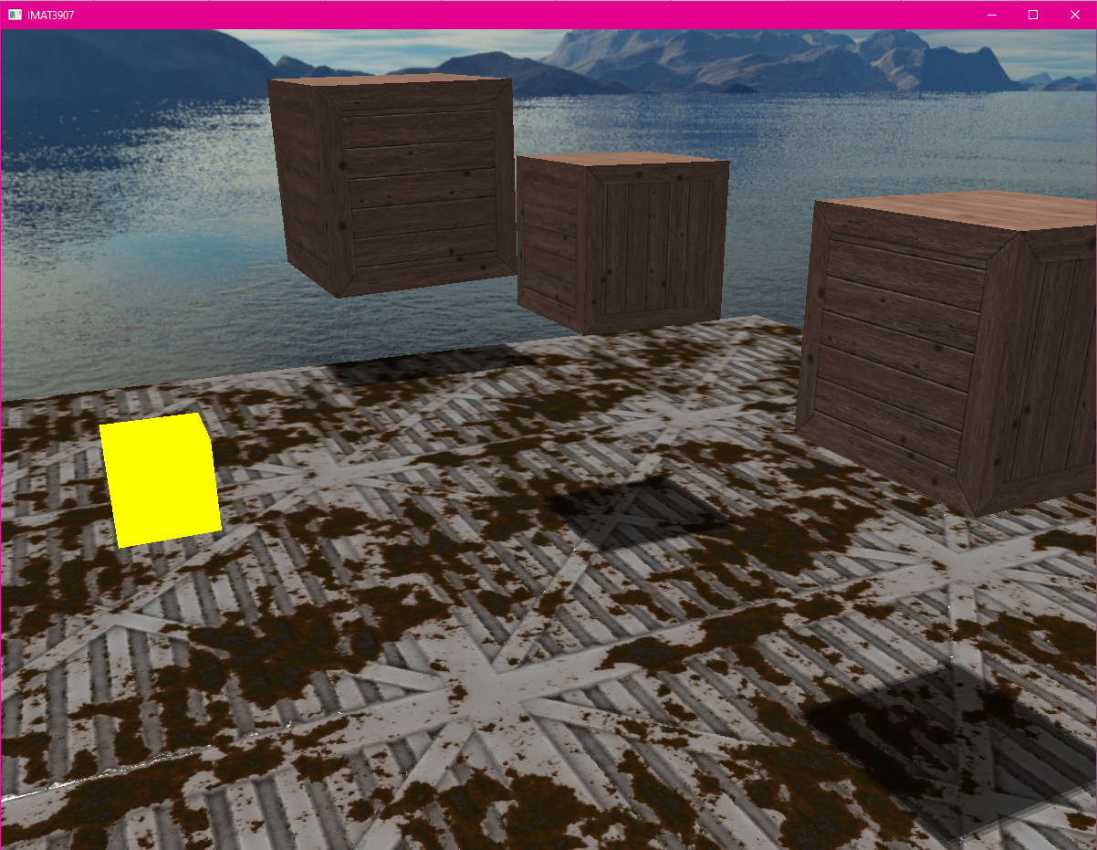  
Figure 30: Shadow mapping

**Cube Mapping**

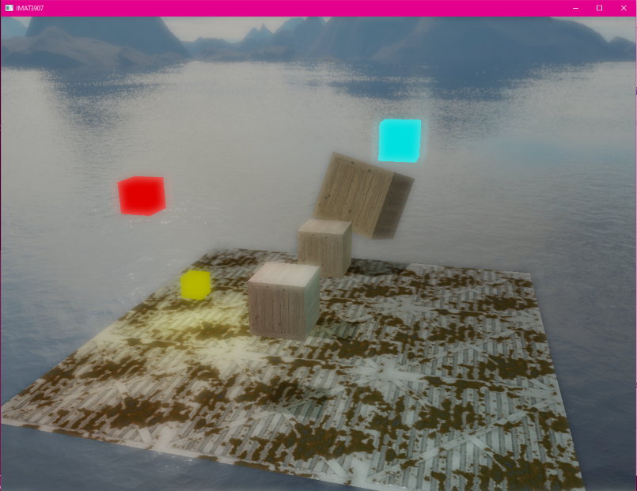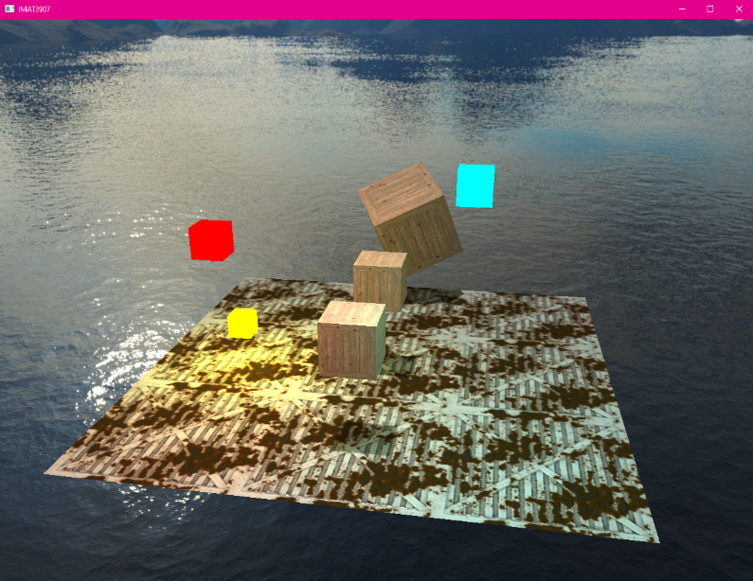Using Cube Mapping I created a skybox for my scene, I first had a problem with the skybox overlaying the floor and cubes, but the issue was fixed when I made the skybox be the first thing that rendered in my scene. With the skybox I included, although it looks nice on its own, it doesn’t fit the ambience of my scene, with more time I would find or create my own skybox that would better match the theme of my scene.   
Figure 31: Point light and directional light only on left, bloom added on right, looks better with bloom but still not right tone for scene with this skybox.

**Profiling and debugging**

Using a program called RenderDoc, I can load the Shader program and debug the rendered scenes. By taking frame captures I can look at the inputs and outputs in the texture viewer and how the scene is rendered during the graphics pipeline stages.

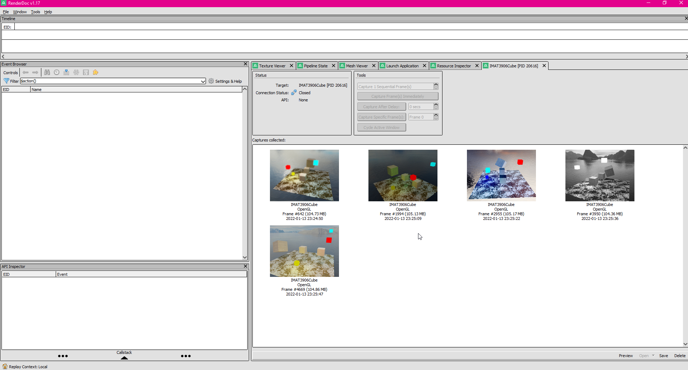  
Figure 32: Frame captures in RenderDoc

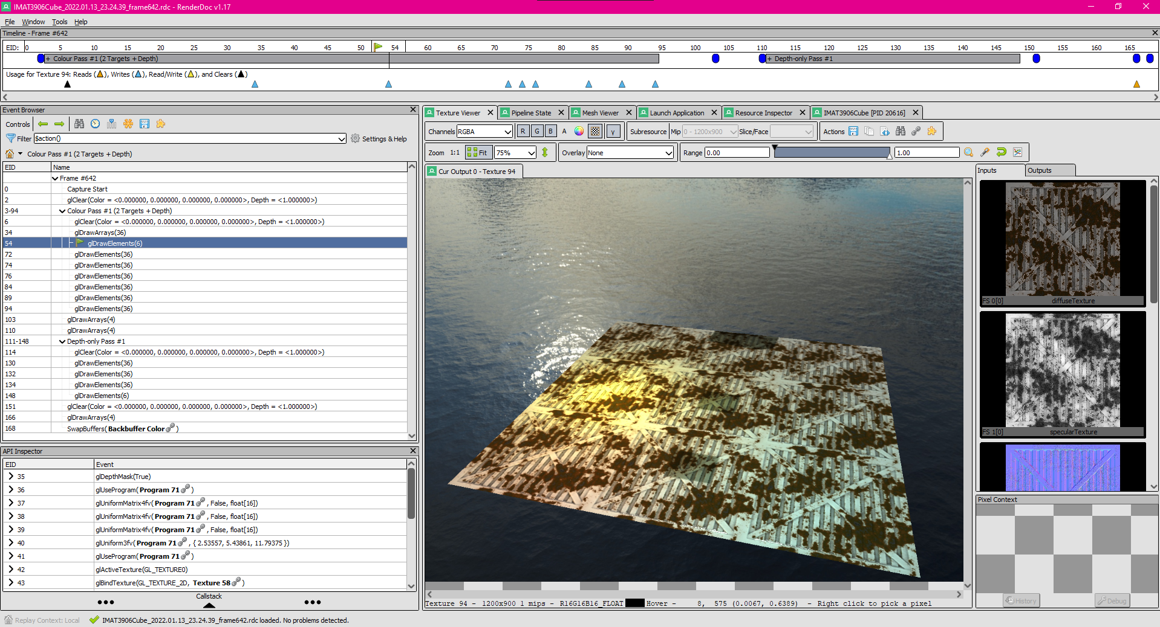  
Figure 33: Texture Viewer in RenderDoc

I also used this to debug any errors I had with my shader program, an example of this was when I was working on Shader Mapping, I had my shadow being rendered over the top of the cube instead of underneath it, as shown in figure 33. Using RenderDoc I could see that it was being rendered first which allowed me to figure out where the problem was and fix the shadow mapping.

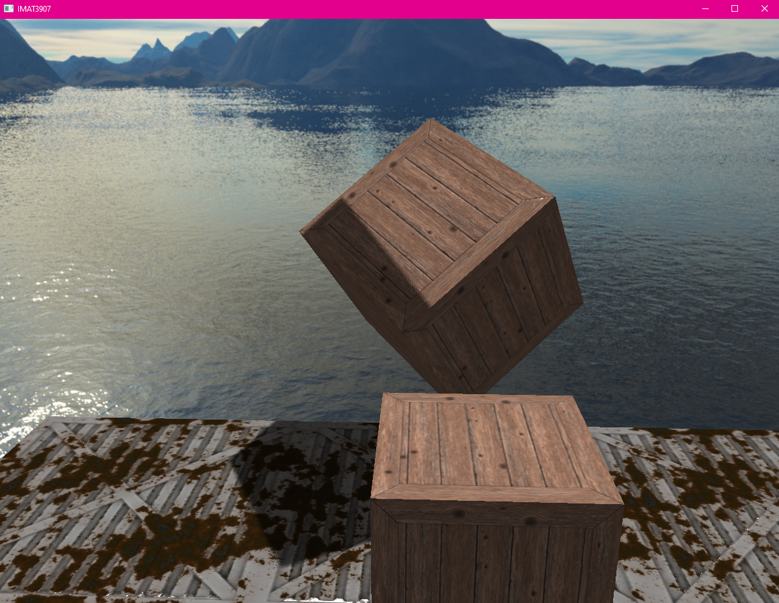  
Figure 34: Shadows rendering on top of cube

**Conclusion**

In conclusion, I am pleased at the result and feel I have successfully created a working shader program with a variety of light casters and post processing techniques.

**Toggle Keys for Shader Program**

|  |  |
| --- | --- |
| Key | Action |
| 1 | Directional Light |
| 2 | Spotlight |
| 3 | Point Lights |
| 4 | Rim Light |
| 5 | Reinhard Tone Mapping |
| 6 | Bloom brightness |
| 7 | Invert |
| 8 | Greyscale |
| 9 | Gamma correction filter |
| TAB | Depth Map |
| B | Bloom |
| Q | Gaussian Blur |

**References**

[1] OpenGL Superbible 7th edition, Sellers et. Al, Chapter 13

[2] LearnOpenGL, “Basic Lighting”. LearnOpenGL. https://learnopengl.com/Lighting/Basic-Lighting (Accessed: 13 Jan 2022).

[3] OpenGL Programming Guide. ”Chapter 5 Lighting”. Available at: https://www.glprogramming.com/red/chapter05.html [Accessed 13 Jan. 2022].

[4] LearnOpenGL, “Light Casters”. LearnOpenGL. <https://learnopengl.com/Lighting/Light-casters> (Accessed: 13 Jan 2022).

[5] LearnOpenGL, “HDR”. LearnOpenGL. <https://learnopengl.com/Advanced-Lighting/HDR> (Accessed 13 Jan 2022)

[6] LearnOpenGL, “Bloom”. LearnOpenGL. <https://learnopengl.com/Advanced-Lighting/Bloom> (Accessed 13 Jan 2022)

[7] LightHouse3D. GLSL Tutorial - Point Lights. Available at: https://www.lighthouse3d.com/tutorials/glsl-tutorial/point-lights/ [Accessed 13 Jan. 2022].

[8] LightHouse3D. GLSL Tutorial - Point Lights. Available at: <https://www.lighthouse3d.com/tutorials/glsl-tutorial/spotlights/> [Accessed 13 Jan. 2022].

[9] LearnOpenGL, “Normal Mapping”, LearnOpenGL. <https://learnopengl.com/Advanced-Lighting/Normal-Mapping> (Accessed 13 Jan 2022)

[10] LearnOpenGL, “Cube maps”, LearnOpenGL. <https://learnopengl.com/Advanced-OpenGL/Cubemaps> (Accessed 13 Jan 2022)

[11] Humus. Textures. Available at: http://www.humus.name/index.php?page=Textures [Accessed 13 Jan. 2022].

[12] 3D Textures. 3D Textures. Available at: https://3dtextures.me/ [Accessed 13 Jan. 2022].

[13] LearnOpenGL, “Parallax Mapping”, LearnOpenGL. <https://learnopengl.com/Advanced-Lighting/Parallax-Mapping> (Accessed 13 Jan. 2022)

[14] OpenGL Wiki. (n.d.). Framebuffer. [online] Available at: https://www.khronos.org/opengl/wiki/Framebuffer [Accessed 13 Jan. 2022].

[15] LearnOpenGL, “Shadow Mapping”. LearnOpenGL. <https://learnopengl.com/Advanced-Lighting/Shadows/Shadow-Mapping> (Accessed 13 Jan 2022)